Preliminary Assessment of Increased Natural Recharge Resulting from Urbanization and Stormwater Retention within the City of Chandler

TABLE OF CONTENTS

Executive Summary 3
1.0 Introduction 4
1.1 Project Background 4
1.2 Project Approach 4
1.3 Report Overview 5
2.0 Groundwater recharge and effects of urbanization 5
2.1 Recharge Mechanisms 5
2.2 Precipitation 6
2.3 Estimated Pre-urbanized recharge 6
2.3.1 U.S. Geological Survey Regional Aquifer Systems Analysis 6
2.3.2 Arizona Department of Water Resources Salt River Valley Groundwater Flow Model 7
2.4 Effect of Urbanization on Groundwater Recharge 7
2.5 Natural Groundwater Recharge and Urbanization Summary 8
3.0 Precipitation Analysis 8
4.0 ESTIMATES OF LAND SURFACE CHARACTERISTICS 11
4.1 Data Sources 11
4.2 Land Surface Cover Approach 12
4.2.1 Impervious Surface Analysis 12
4.2.1.1 City Land Use Classification 12
4.2.1.2 Impervious Surface Area from Satellite Imagery 13
4.2.1.3 ADWR Land Use Categories 14
4.2.1.4 Impervious Surface Area Conclusion 14
4.2.2 Turfgrass Analysis 14
4.2.3 Other 14
4.3 Land Use Category Approach 15
4.4 Drywell Analysis 16
4.5 Stormwater Detention Basin Analysis 19
5.0 Stormwater Runoff Estimates 19
6.0 ENHANCED GROUNDWATER Recharge Estimates 22
6. 1 Groundwater Recharge Estimates from Land Surface Cover Method 22
6.2 Groundwater Recharge Estimates from Land Use Category Method 23
6.3 Turfgrass and Agriculture Land Infiltration and Groundwater Recharge 24
6.4 Estimated Groundwater Recharge Summary 25
7.0 Conclusions 25
8.0 References 27

TAbles and Figures

Table 1. Analysis of NWS weather station precipitation data
Table 2. Average cumulative precipitation per event, average number of events per year and percent of total annual precipitation for storms in each precipitation range
Table 3. Estimated land cover surface percentages
Table 4. Estimated land use category percentages
Table 5. Drywells by study land use classification
Table 6a. NRCS-CN Method runoff estimates by surface cover type
Table 6b. NRCS-CN Method runoff estimates by land use category
Table 6c. Estimated total annual runoff and percent of total runoff by precipitation range
Table 7. Estimated groundwater recharge estimates from Land Surface Cover runoff
Table 8. Estimated groundwater recharge from Land Use Category runoff.
Table 9. Turfgrass and agriculture groundwater recharge estimates
Table 10. Estimated groundwater recharge summary
Table 11. Chandler Groundwater Recharge Budget

Figure 1. Study area
Figure 2. Location of NWS weather stations used to characterize precipitation in the Chandler area.
Figure 3. Annual precipitation and wet, normal, and dry years for Chandler area based on the historical mean and one standard deviation.
Figure 4. Example of impervious surface cover for Medium Lot Residential Land Use.
Figure 5. Impervious surface area map generated from AZ ISA map (ADWR 2004).
Figure 6a. Location of drywells from geo-coding of ADEQ drywell database
Figure 6b. Location of drywells from City of Chandler drywell database
Figure 7. Example of association of drywells with passive open space.

Executive Summary
A preliminary evaluation of the increase in groundwater recharge resulting from engineered stormwater capture and retention in the City of Chandler was performed. The City captures all stormwater runoff in drywells and retention basins, from which it either evaporates or infiltrates. Consequently, a significant portion of stormwater runoff may result in groundwater recharge. Increased recharge from urbanization represents a potentially valuable resource for the City’s water budget; this study provides an initial estimate of that amount.
Historic precipitation records were analyzed to determine the precipitation characteristics of dry, normal, and wet years. These data were combined with land use and surface cover data to generate estimates of stormwater runoff within the city limits. The fraction of runoff that evaporates was then estimated, and the remainder of runoff was assumed to infiltrate through drywells and retention basins. Deep percolation resulting from direct infiltration through turfgrass and agriculture was also estimated.
Study findings include:
- In an average year, approximately 24,800 acre-feet of precipitation falls within the city limits. Dry years and wet years average 13,550 and 47,200 acre-feet, respectively.
- Pre-development groundwater recharge rates are negligible (less than 191 acre-feet per year).
- More than 3,800 drywells exist within the City of Chandler along with an estimated1400 acres of stormwater retention basins
- An estimated 3,700 to 4,800 acre-feet of stormwater runoff reaches retention basins and drywells during an average year. Dry and wet year runoff volumes average 1,500 and 10,900 acre-feet, respectively.
- An average of 2,100 to 3,100 acre-feet per year are estimated to recharge in Chandler drywells and stormwater retention basins over a 10-year period.
- An estimated 1,250 acre-feet per year of groundwater recharge is estimated to result from direct precipitation on turfgrass and agricultural lands.
- 3,900 to 4,600 acre-feet per year of potential groundwater recharge is estimated to occur over a ten-year period. Dry and wet year potential groundwater recharge volumes are 1,400 and 10,900 acre-feet, respectively.
- As Chandler continues to urbanize, groundwater recharge resulting from stormwater capture and retention is likely to increase.

1.0 Introduction
This report presents the results of a preliminary assessment conducted by GeoSystems Analysis Inc. (GSA) to estimate the amount of natural groundwater recharge that results annually from precipitation within the City of Chandler (City). Estimating groundwater recharge rates is becoming more important to communities in the arid Southwest as they develop assured water supplies and meet safe-yield goals for groundwater resources. Increased groundwater recharge resulting from urbanization and stormwater retention represents a potential additional source of assured water supply. The City contains and controls all stormwater runoff within its boundaries through the use of drywells and retention basins. This stormwater may substantially increase groundwater recharge rates, therefore estimates of the magnitude of that increase are needed.

1.1 Project Background
Natural groundwater recharge in the Southwest is believed to occur primarily in mountain front areas and in ephemeral stream channels, with negligible groundwater recharge occuring in inter-channel areas. Urbanization causes increased stormwater runoff due to the increase in impervious surfaces. The increased runoff routed into channels, retention basins, and drywells may also increase local groundwater recharge.

1.2 Project Approach
The amount of groundwater recharge that occurs from precipitation is directly correlated to the intensity and frequency of precipitation events, the amount of runoff generated, and the volume of runoff that can infiltrate and reach the groundwater system. In this investigation, each of these parameters was estimated using readily available data and literature-based empirical methods. The study area was defined by the City boundaries (Figure 1).
National Weather Service (NWS) precipitation data from the City and surrounding communities were used to determine the intensity and frequency of storms, and characteristics of wet, dry, and normal precipitation years for the Chandler area. Next, estimates of land cover use were made from GIS land use data combined with aerial photos to define stormwater runoff coefficients. Runoff from storms during wet, dry and normal years then was predicted using the National Resources Conservation Service - Curve Number (NRCS-CN) method. Finally, groundwater recharge was estimated to equal the fraction of runoff that does not evaporate and deep percolation through turf grass and agricultural land.

1.3 Report Overview
Section 2 presents a discussion on groundwater recharge in the Southwest and the effects of urbanization. Section 3 presents the results of the precipitation analysis for the Chandler Area. Section 4 presents results of the land surface cover analysis for the City. Section 5 presents storm water runoff estimates for the City. Section 6 gives estimates of groundwater recharge for the City. Sections 7 and 8 contain project conclusions and recommendations. Finally, Appendix I provides supporting calculations.
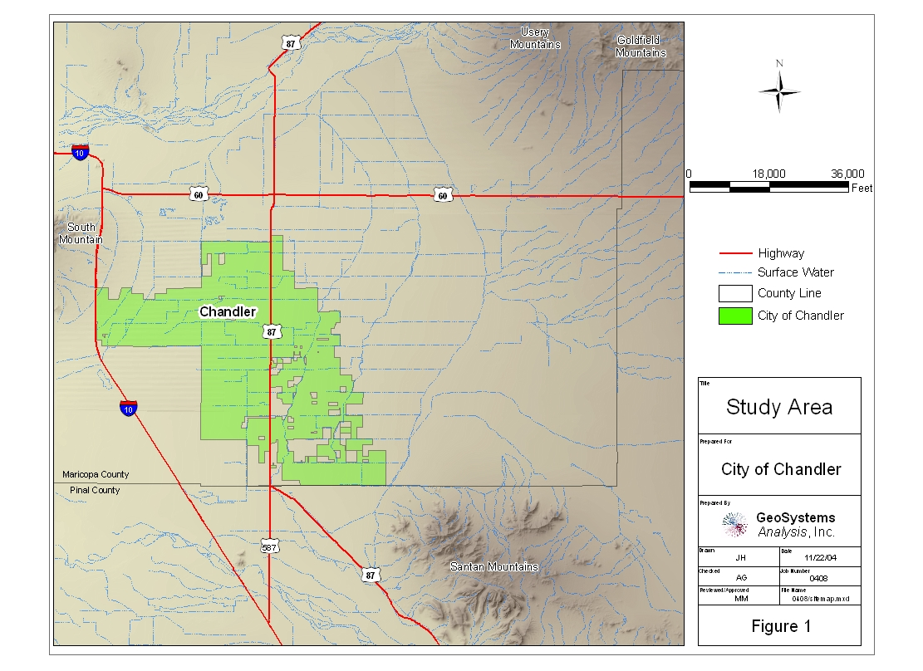
Figure 1. Study area

2.0 Groundwater recharge and effects of urbanization
Groundwater recharge is defined herein as water that penetrates the land surface into the subsurface (infiltration), moves through the zone of evapotranspiration into the deeper unsaturated or vadose zone (deep percolation), and reaches an aquifer. In natural settings, recharge by deep percolation occurs in three principle ways: a) through soils and the vadose zone in inter-drainage areas; b) through streambeds, and c) through localized concentrations of water (i.e. basins) in the absence of well-defined channels (Lerner et al., 1990). The relative importance of each of these recharge pathways is the subject of ongoing research, but the settings appear to correlate strongly to local and regional geology and geomorphology, and climate and weather patterns.

2.1 Recharge Mechanisms
Research in the southwestern United States indicates that, on an annual basis, potential evapotranspiration exceeds precipitation, thus recharge depends strongly on high-intensity rainfall events, accumulation of rain water in depressions and streams, and the ability of rain water to percolate deeply and rapidly through cracks, fissures, or stream channels (Devries and Simmers, 2002). Scanlon et al. (1999) found that in the Chihuahan desert, groundwater recharge rates in ephemeral stream channels and localized depressions were several orders of magnitude greater than recharge rates in inter-channel areas. Pool (2004), in a study of ephemeral stream channel recharge in southeastern Arizona, found that annual stream flow volumes and estimated recharge rates increased three- to four-fold from 1933 to 1999. Although the majority of the increase was believed to be due to the increased frequency of El Niño years and associated increased stormwater runoff, greater increases in recharge were also observed in urbanized versus non-urbanized watersheds. In urbanized watersheds such as in the Chandler area, the addition of retention basins and drywells greatly increases the number of recharge paths.

2.2 Precipitation
Precipitation in the Southwest occurs primarily during the winter and summer seasons. Late fall and winter precipitation is characterized by slow-moving frontal storms that bring low-intensity, but relatively long-duration precipitation events. Summers bring heat-driven convective thunderstorms of brief duration but often very high intensity. These high-intensity storms tend to generate rapid runoff across sparsely vegetated desert floors. The short duration of these convective storms and extreme heating between storm events promotes rapid drying of the soil profile. Winter storm events, however, have the effect of slowly wetting the soil profile. Combined with the effects of cooler temperatures and lower transpiration rates of dormant plants in the winter, soil moisture deficits gradually decrease, leading to downward hydraulic gradients necessary for recharge (GSA, 2004).

2.3 Estimated Pre-urbanized recharge
Several authors have shown that very little (less than one percent of annual precipitation) groundwater recharge occurs in arid environments (Scanlon et al., 1999; Allison et al., 1994, Gee and Hillel, 1988; Gee et al., 1993). Most recently, Scanlon et al. (2003) proposed that in the Chihuahuan and Amargosa deserts and in the High Plains, recharge rates in interdrainage areas are negligible, and upward drying trends have been occurring for several thousand years. Similarly, groundwater recharge prior to the 20th century development of Chandler most likely occurred in the natural stream channels and nearby mountain areas.
Other than costly and time-consuming direct in-situ measurements, no reliable methods exist to estimate natural groundwater recharge rates semi-arid settings in small inter-basin areas such as Chandler. Most approaches either rely on empirical relationships (i.e. Maxey-Eakin, 1949) or require calibration of basin-scale groundwater flow models. Two methods, the Regional Aquifer Systems Analysis (Anderson et al., 1992) and the Arizona Department of Water Resources Salt River Valley Groundwater Flow Model (Correll and Corkhill, 1994), were applied to the City.

2.3.1 U.S. Geological Survey Regional Aquifer Systems Analysis
The U.S. Geological Survey’s Regional Aquifer Systems Analysis (RASA) (Anderson et al., 1992) identified mountain front recharge as a major component of recharge in the hydrologic basins of southeastern Arizona. Mountain front recharge was defined as “the water that infiltrates into the zone of coarse alluvium that extends several miles basinward from the mountain-basin interface.”
Taking into account differences in geology, topography, vegetation, and surface runoff characteristics, the RASA developed an empirical equation for estimating mountain front recharge . The equation was developed from water budget analyses using 12 separate numerical groundwater flow models for individual hydrologic basins in Arizona and Nevada:
log Qrech=-1.40+0.98log P, where P>8
where Qrech is the average mountain front recharge and P is the total annual volume of precipitation over the watershed in excess of 8 inches (P>8).
The authors caution against using the estimation equation for small watersheds and isolated areas, especially where estimated mountain front recharge is less than 1000 acre-feet per annum (afa). Nonetheless, applying the equation to the City of Chandler watershed, with a total area of 39,000 acres and an average annual precipitation of 8.3 inches, yields a recharge rate of 49 afa.

2.3.2 Arizona Department of Water Resources Salt River Valley Groundwater Flow Model
The Arizona Department of Water Resources developed a regional groundwater flow model of the Salt River Valley (SRV), including the City of Chandler. As part of the study, the major groundwater recharge components of the pre-development (circa 1900) hydrologic system were identified: perennial and ephemeral stream channel infiltration and mountain front recharge (Corell and Corkhill, 1994). The natural recharge estimated for the 2,240 square-mile SRV study area was 108,000 afa, or 0.075 afa per acre. However, the absence of perennial and large ephemeral stream channels within the Chandler city limits (Reynolds, 2004) suggests that it is unlikely that predevelopment recharge rates were this high in that area. If the perennial and ephemeral stream channel components are removed from the SRV model estimates, the result is an average recharge rate of 0.005 afa per acre, equivalent to 191 afa within the City. As only two small contributing mountain front areas exist near Chandler, this value likely represents the upper limit of pre-development natural groundwater recharge, and includes groundwater recharge associated with stormwater runoff into small ephemeral drainages within the City.

2.4 Effect of Urbanization on Groundwater Recharge
In the Southwest, urbanization can increase the recharge that occurs through ephemeral channels because interdrainage areas are sealed off by impermeable surfaces such as parking lots, roads, and buildings. The impermeable surfaces cause a greater fraction of precipitation to become stormwater runoff captured in drainages, retention basins and drywells. Most importantly, runoff may occur under precipitation events that would not have generated runoff under pre-urbanized conditions. Urbanization in Los Angeles County has resulted in a tenfold increase in runoff over the last several decades, according to the Los Angeles and San Gabriel Rivers Watershed Council (2003).
GSA (2004) examined the potential for enhancing natural groundwater recharge rates through stormwater capture in the Upper San Pedro Basin in southeastern Arizona. Surface water modeling predictions suggested that urbanization could result in a two- to four- fold increase in stormwater runoff and a 500 percent increase in infiltration volumes over pre-urbanized values. The higher increases in runoff observed in Los Angeles County as compared with modeled results for the San Pedro Basin may be attributed to greater urbanization and concrete lining of flood control channels in Los Angeles County.
The presence of turfgrass and agriculture within the City will also contribute to increased groundwater recharge from precipitation. Turfgrass and agriculture are normally irrigated at rates slightly exceeding the evapotranspirative demand, therefore a portion of the precipitation that infiltrates into these areas will also percolate into groundwater.

2.5 Natural Groundwater Recharge and Urbanization Summary
Estimated pre-urbanized groundwater recharge rates within the City are less than 191 afa. The presence of retention basins and drywells and the complete capture of stormwater runoff could result in significant additional groundwater recharge. Furthermore, groundwater recharge above estimated pre-urbanized recharge levels is not adjudicated.

3.0 Precipitation Analysis
Groundwater recharge from precipitation is directly dependent on precipitation intensity and frequency. Precipitation and stormwater runoff during wet years can substantially increase the amount of potential recharge above a “normal” (average) year. To understand the precipitation variations experienced in Chandler, precipitation records for the city were examined and precipitation frequencies representing dry, normal, and wet years were developed.
NWS daily precipitation data for the City and surrounding communities were obtained from the Western Regional Climate Center (http://www.wrcc.dri.edu). The daily precipitation record for the City covers 1948 through 1980, but the record is complete for only 27 years, which is not sufficient to determine long-term precipitation patterns for the City. Regional climate studies show a sustained drought occurred in the 1950s, part of a multidecadal dry period spanning 1947 to 1976 (McPhee et al., 2004). Additionally, the Chandler record excludes the wettest periods in the past century, 1925 to 1946 and 1977 to 1998 (McPhee et al., 2004).
To overcome the limitations of the Chandler data, daily precipitation data from NWS weather stations within a 16 mile radius of downtown Chandler (Figure 2) were analyzed to account for spatial variability and to obtain more than 100 years of daily precipitation data from which to characterize precipitation intensity and frequency. The daily precipitation records included: Chandler (1948 – 1980), Chandler Heights (1948 – 2004), Mesa (1896 – 2004), Tempe ASU (1953-2004), and Tempe 3 (1905 – 1952). Except for the period 1896-1904 when only one data set was available, at least two daily precipitation values were averaged for each day to determine: 1) the number of storms per year in the precipitation ranges of: 0 to 0.2 inch, 0.2 to 0.4 inch, 0.4 to 0.6 inch, 0.6 to 0.8 inch, 0.8 to 1.0 inch, and greater than 1.0 inch; 2) the average precipitation for each precipitation range; and 3) the average number of storm events in each precipitation range for dry, normal, and wet years.
Each year in the historical precipitation record for the five Chandler area stations was classified as dry, normal, or wet. Normal years were defined as those when the annual precipitation was within one standard deviation of the mean for the period of record. Dry and wet years were defined as years having annual precipitation less or greater than one standard deviation from the mean, respectively. Table 1 shows the annual mean precipitation, standard deviation and number of dry, normal, and wet years for each station. Figure 3 shows the annual precipitation and the dry, normal, and wet years for the Chandler area.
Based on the historical record, the average annual precipitation for the City is 8.3 inches per year, and approximately 12% of the years being dry and 11% being wet. This roughly corresponds to eight normal, one dry and one wet year per every ten year period.
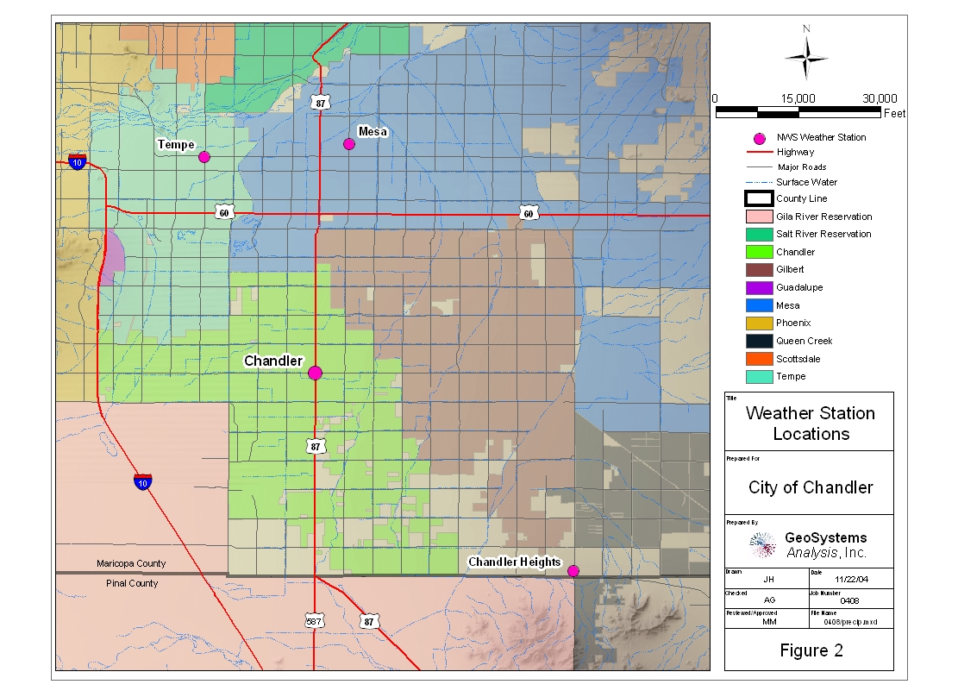
Figure 2. Location of NWS weather stations used to characterize precipitation in the Chandler area.

Table 1. Analysis of NWS weather station precipitation data
Station | Years in Record | Annual Mean Precipitation (inches) | Std Dev. (inches) | Dry | Normal | Wet
 |  |  |  | (Number of Years)
Chandler | 27 | 6.9 | 2.66 | 2 | 23 | 2
Chandler Heights | 52 | 8.9 | 3.38 | 6 | 40 | 6
Mesa | 106 | 8.3 | 3.20 | 15 | 77 | 14
Tempe* | 96 | 8.5 | 3.49 | 11 | 76 | 10
Average** | 70 | 8.3 | 3.16 | 8.5 | 54 | 8
*Combined record of NWS stations Tempe 3 and Tempe ASU
**Average weighted by years in record
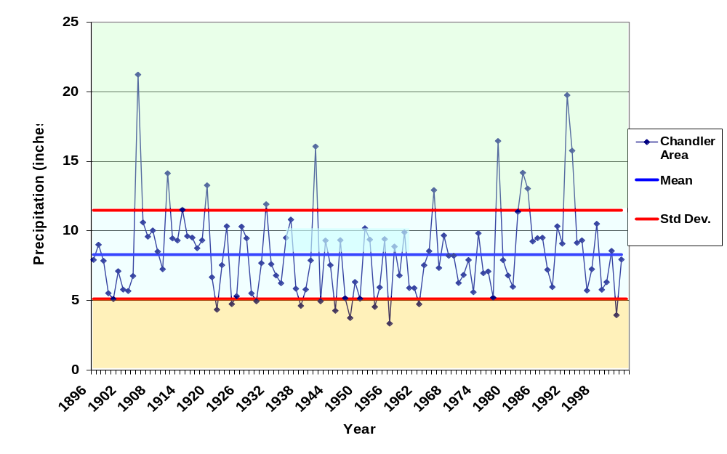
Figure 3. Annual precipitation and wet, normal, and dry years for Chandler area based on the historical mean and one standard deviation.

Dry, normal, and wet precipitation years were further characterized by taking the weighted average (based on years in record) of the number of storms in each precipitation range and the average total precipitation per storm event (Table 2). The number of events per precipitation range decreases with increasing precipitation intensity. Moreover, the increase in average number of events per year between the dry, normal and wet years is most significant for the larger precipitation ranges.
Table 2. Average cumulative precipitation per event, average number of events per year and percent of total annual precipitation for storms in each precipitation range
Precipitation Range (inches) | 0 - 0.2 | 0.2 - 0.4 | 0.4 - 0.6 | 0.6 - 0.8 | 0.8 - 1.0 | Above 1.0
 | Average precipitation per event (inches)
Dry Year | 0.07 | 0.29 | 0.48 | 0.70 | 0.90 | 1.46
Normal Year | 0.08 | 0.29 | 0.49 | 0.69 | 0.91 | 1.36
Wet Year | 0.08 | 0.30 | 0.50 | 0.70 | 0.90 | 1.43
 | Average number of events per year
Dry Year | 17.4 | 4.5 | 1.5 | 0.5 | 0.3 | 0.3
Normal Year | 20.1 | 6.1 | 2.9 | 1.6 | 0.9 | 1.0
Wet Year | 27.1 | 8.9 | 5.2 | 2.8 | 1.8 | 3.0
 | Percent of total annual precipitation
Dry Year | 29 percent | 30 percent | 16 percent | 8 percent | 7 percent | 10 percent
Normal Year | 19 percent | 23 percent | 18 percent | 14 percent | 10 percent | 16 percent
Wet Year | 14 percent | 17 percent | 17 percent | 13 percent | 10 percent | 28 percent

4.0 ESTIMATES OF LAND SURFACE CHARACTERISTICS
Methods to estimate stormwater runoff from various surfaces rely on estimates of the surface roughness and permeability. These values are derived directly from knowledge of a particular land surface, or indirectly from land use classification data. Two approaches were taken to define land surfaces in the City: land surface cover (i.e. impervious, turfgrass), and land use classification (i.e. zoning type). In the land surface cover approach, the land surface was divided into six cover categories, for which runoff curve numbers were estimated from SCS (1986) and used to estimate runoff (Section 5.0). In the land use classification approach, the land was divided into ten land use categories based on available land use data to estimate the extent and distribution of various surface types. A single composite runoff curve number (SCS, 1986) was then used to describe runoff from the mix of surfaces within each land use category.
GSA estimated the extent of various land surface covers using city, county and state geographic information system (GIS) land use data and aerial photos. The accuracy of this approach was somewhat limited by the fact that the actual land use, determined from the aerial photos, did not always agree with the GIS-listed land use which includes intended as well as actual land use. Additionally spatial errors in the GIS plots can cause errors in surface cover estimates. Thus, the accuracy of this method is strongly dependent on the temporal agreement and spatial accuracy of the land use classification data and aerial photos.

4.1 Data Sources
The following data sources were used to estimate land surface cover, stormwater detention basins, and the aerial extent of dry wells:
1. Aerial Photographs – November 2003 City aerial photographs show the land cover, parcels, and degree of development.
2. Chandler land use layer –GIS layer provided by the City contains the land use classifications developed by the City’s zoning department. The City is divided into parcels, each classified according to current or intended land use.
3. ADEQ drywell layer –GIS layer based on the Arizona Department of Environmental Quality (ADEQ) drywell database which contains 1,076 drywell records representing 3,763 drywells.
4. City of Chandler drywell layer –GIS layer provided by the City contains 1,941 drywells that have been verified and located in the field with Global Positioning System (GPS) units.
5. Arizona Impervious Surface Area –GIS layer was developed by ADWR (2001) using methods originally provided through NASA’s Land Cover Land Use Change Program. It contains estimates of percent impervious surface on a 1-km grid for the entire state.
6. ADWR land use and land surface cover (ADWR 1996) – Previous estimates of eight land surface covers associated with 12 land use classes were made in a study of drywell recharge in metropolitan Phoenix. Average land surface covers were measured on the ground in test sections for each land use class, then weighted per land use class to estimate land surface cover for the entire study area based on land use class. For this study, ADWR land surface cover estimates were combined with the Chandler land use layer to estimate percent impervious surfaces in Chandler.

4.2 Land Surface Cover Approach
The first approach used to derive land surface data for stormwater runoff modeling was to determine the extent of various surface covers in the city, and to model runoff from each surface type as a continuous, homogenous surface. For this approach, all surface area in the city was classified as either impervious, turfgrass, agriculture, vacant, water, or other.

4.2.1 Impervious Surface Analysis
Stormwater runoff is strongly affected by the presence of impervious surfaces, therefore, the percent impervious surface was estimated by three different methods to determine the most accurate estimate possible.

4.2.1.1 City Land Use Classification
One test section was selected for each of the City’s 43 land use categories to estimate the amount of roads, sidewalks, and rooftops from the aerial photos. Figure 4 shows the designated impervious surface area for the Medium Lot Residential land use category.
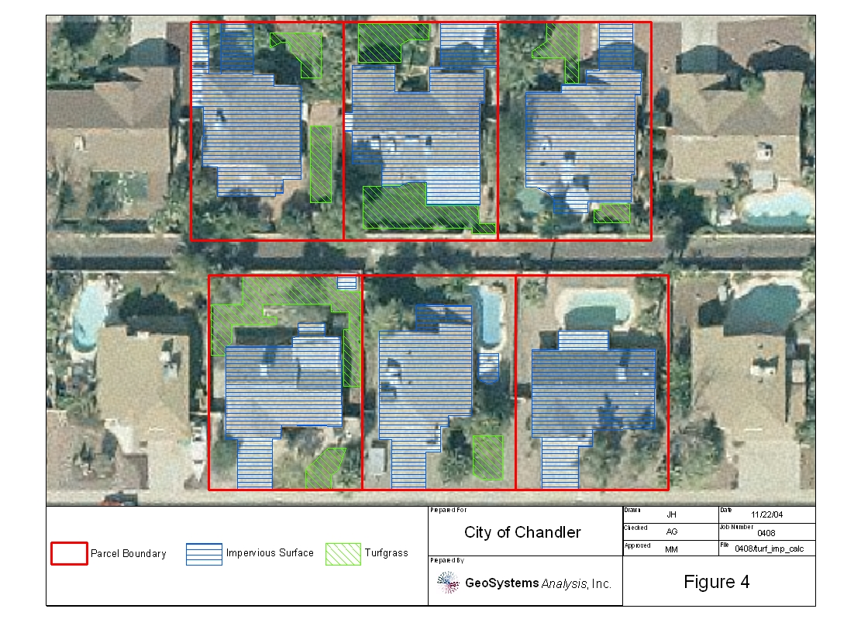
Figure 4. Example of impervious surface cover for Medium Lot Residential Land Use.
The percent impervious surface area for all parcels in each test section were averaged to obtain the fraction of impervious surface for each land use category. The total impervious surface for each category was then obtained by multiplying the appropriate impervious fraction by the total surface area of that category. Using this method, the total impervious surface cover in the City was estimated to be 11,300 acres.

4.2.1.2 Impervious Surface Area from Satellite Imagery
Estimates of impervious surface cover for the City were also made using the Arizona Impervious Surface Area (AZ ISA) 2001 GIS data (ADWR 2001). The AZ ISA estimates provide the percent impervious surface on a 1-km grid of Arizona. Slight differences between the grid dimensions and the city boundaries meant that some of the AZ ISA layer extended beyond the study area, and in other places, coverage within the study area was missing (Figure 5). The impervious surface percent for each category was multiplied by the coverage area of that category in the city, and then the total for all categories was combined to yield the impervious surface area for the city. This value was then normalized to correct for the difference between the coverage area and the actual area of the city. Using this method, the impervious surface in Chandler was estimated to be 10,500 acres.
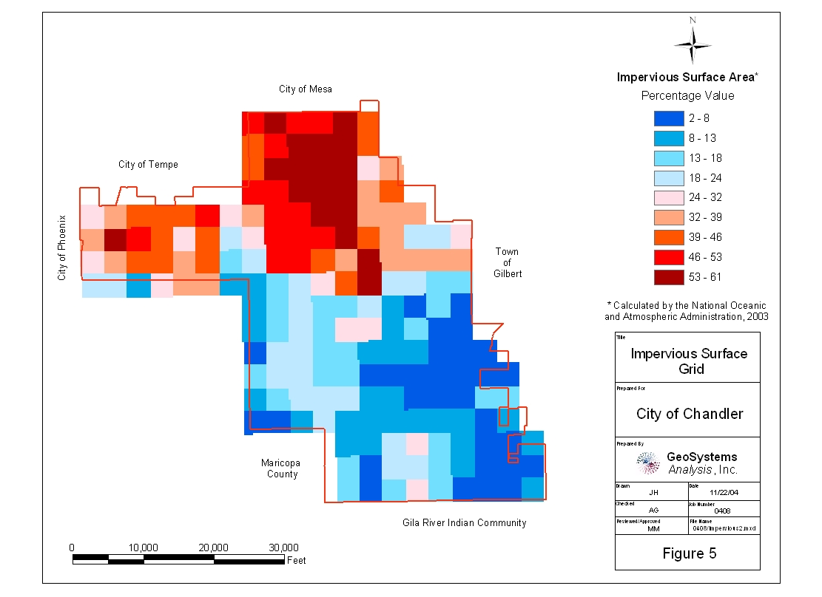
Figure 5. Impervious surface area map generated from AZ ISA map (ADWR 2004).

4.2.1.3 ADWR Land Use Categories
The third estimate of impervious surface cover for the City was made using the previously described ADWR land use and land surface cover study estimates (ADWR 1991). The 43 Chandler land use categories were combined to fit into the 12 ADWR land use categories. The ADWR land use-impervious surface relationship was then used to estimate impervious surface for the City. Using this method, the impervious surface in Chandler was estimated to be 8,100 acres.

4.2.1.4 Impervious Surface Area Conclusion
The land surface cover classification estimate of 11,300 acres of impervious surface area (28 percent of total) using the City GIS and aerial photography data is believed to be the most reliable estimate (Table 3) because it is the most direct, current, and site-specific. The ADWR estimates are based on Phoenix land use characteristics in the early 1990s, which may not accurately reflect the current land use in Chandler. The ISAAZ data are more current and generally agree (within 7 percent) with the City land use classification estimate.

4.2.2 Turfgrass Analysis
Estimates of turfgrass cover for the City were made using aerial photos combined with City land use GIS data. One test section was chosen for each of the City’s 43 land use categories and estimates of turfgrass surface were made from the aerial photos. Figure 4 shows an example of the estimated turfgrass surface area for the Medium Lot Residential category. The average turfgrass areas in each land use category were used to estimate the total turfgrass surface in the City. Using this method, turfgrass cover was estimated to be 4,900 acres (13 percent of total) (Table 3). Because of potential error, turfgrass below trees and rooflines was not estimated; consequently, the turfgrass value is considered conservative.

4.2.3 Agricultural and Vacant Land

4.2.3 Other
Surface area that does not fall into the impervious, turf, agriculture, water, or vacant categories make up 9,800 acres (25 percent of total) (Table 3). This is land situated between buildings, pavement and turfgrass. For runoff estimation purposes, this land was assumed to be sparsely vegetated. An ADWR (1991) study of land cover in the Phoenix area found that, on average, sparse vegetative cover made up 23 percent of the total land cover, comparable to the findings here.
Table 3. Estimated land cover surface percentages
Land Cover | NRCS Curve Number | Total Surface Area  (Acres) | Percent of Total
Impervious | 98 | 11300 | 28 percent
Turf | 66 | 4900 | 13 percent
Agriculture | 75 | 7100 | 18 percent
Vacant | 80 | 5500 | 15 percent
Water | N/A | 400 | 1 percent
Other | 85 | 9800 | 25 percent
Chandler Total |  | 39000 | 100 percent

4.3 Land Use Category Approach
The second approach to determine land use data for runoff modeling was to combine the City’s 43 land use classifications into ten broader classifications based on ADWR’s (1991) study of drywell recharge in Phoenix. All City land was grouped into the following general land use classifications:
- Single Family Residential: Very Large Lot Residential, Large Lot Residential, Medium Lot Residential, Small Lot Residential, Very Small Lot Residential, Rural Residential
- Multi Family Residential: Very High Density Residential, High Density Residential, Medium Density Residential, Mobile Home Residential, Assisted Living
- Commercial: Community Commercial, Convenience Commercial, Downtown Commercial, Neighborhood Commercial, RV/Car/Recreational Vehicle Sales, Regional Commercial, Specialty Commercial, Strip Commercial, Super-Regional Commercial, Tourist and Visitor Accommodations/Hotel, Business Park, Commercial Office and General Services, Office Low Rise, Mid Rise, Warehouse and Distribution Centers
- Industrial and Airports: Airport, Industrial
- Schools, Churches, Hospitals: Church, Institutional, School, Special Events
- Infrastructure: Canal, Public Buildings/Facilities, Rail Road, Streets/Roads
- Parks, Golf Courses: Golf Course, Passive Open Space, Recreation/Open Spaces, Cemeteries
- Agriculture: Agriculture
- Water: Water
- Desert, Vacant Land: Vacant
The surface area for each of the ten land use categories was determined by summing the areas of the specific City land use classifications belonging to each category. Table 4 shows the total surface area and percent of total land for each category. The total surface areas from Table 4 were combined with composite runoff values from the literature to model runoff (Section 5.0).
Table 4. Estimated land use category percentages
Land Use | NRCS Curve Number | Estimated Surface Area (Acres) | Percent of Total
Single Family Residential | 91 | 13,500 | 35 percent
Multi-Family Residential | 94 | 1,500 | 4 percent
Commercial | 96 | 2,000 | 5 percent
Industrial, Airports | 92 | 2,300 | 6 percent
Schools, Churches and Hospitals | 92 | 1,200 | 3 percent
Infrastructure | 98 | 1,900 | 5 percent
Parks, Golf Courses | 78 | 3,300 | 9 percent
Agriculture | 75 | 7,200 | 19 percent
Desert, Vacant Land | 80 | 5,700 | 15 percent
Chandler Total |  | 38,600 | 100 percent

4.4 Drywell Analysis
Drywells are used extensively in the City’s storm water management system. In commercial, industrial, school, church, and hospital areas, drywells are often directly connected to impervious surfaces, whereas in residential areas, drywells are more typically associated with stormwater retention basins. In both cases, the drywells dispose of stormwater runoff by routing it to higher permeability soils in the subsurface.
The aerial extent of drywells in the City was examined using the ADEQ Drywell Registration Database and the City drywell GIS layers combined with aerial photos and City land use GIS data. The ADEQ and City drywell databases are not compatible. Since the ADEQ database does not include coordinates for the drywells, a geo-coding service was used to generate UTM coordinates based on the address provided in each record. However, the accuracy of the geo-coding is limited due to discrepancies between the registration address and the actual drywell location. It was not within the scope of this study to rectify the differences between these two data sources. Figures 6a and 6b show the primary differences between the databases.
The ADEQ database contains roughly twice as many drywells as the City’s database, however, the City data have been ground-truthed, resulting in precise drywell locations. The ADEQ data were assumed to be more accurate with respect to the total number of drywells, and the City data were assumed to be more accurate regarding their locations. Therefore, the number of drywells per land use category was estimated by multiplying the percent of drywells per land use (from the City data) by the total number of drywells in the ADEQ data (Table 5). These estimates were then combined into the ten broader land use categories established in Section 4.3.
Drywells in the passive open spaces were grouped with the Single Family and Multifamily Residential, and the Schools, Churches and Hospitals categories because they usually serve as stormwater retention basins for residential areas. Other significant categories include commercial, industrial and infrastructure drywells directly draining impervious surfaces.
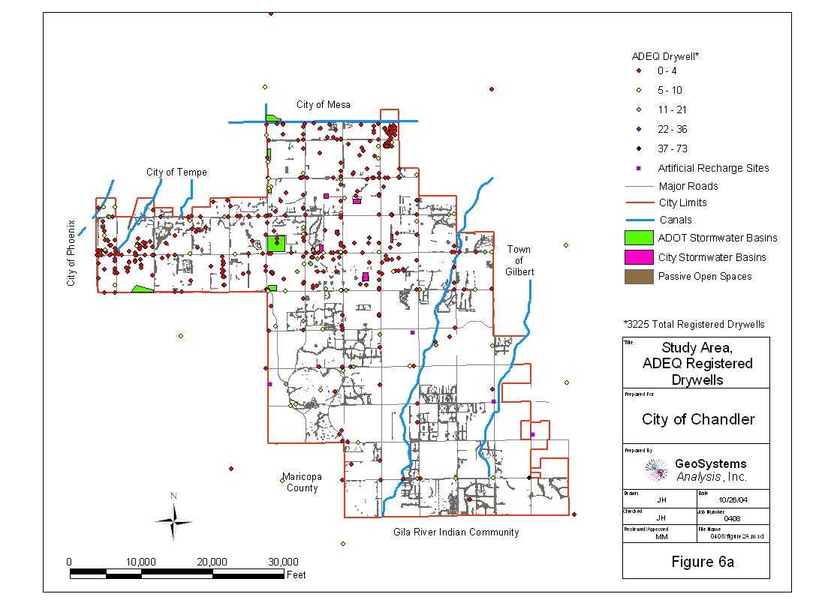
Figure 6a. Location of drywells from geo-coding of ADEQ drywell database
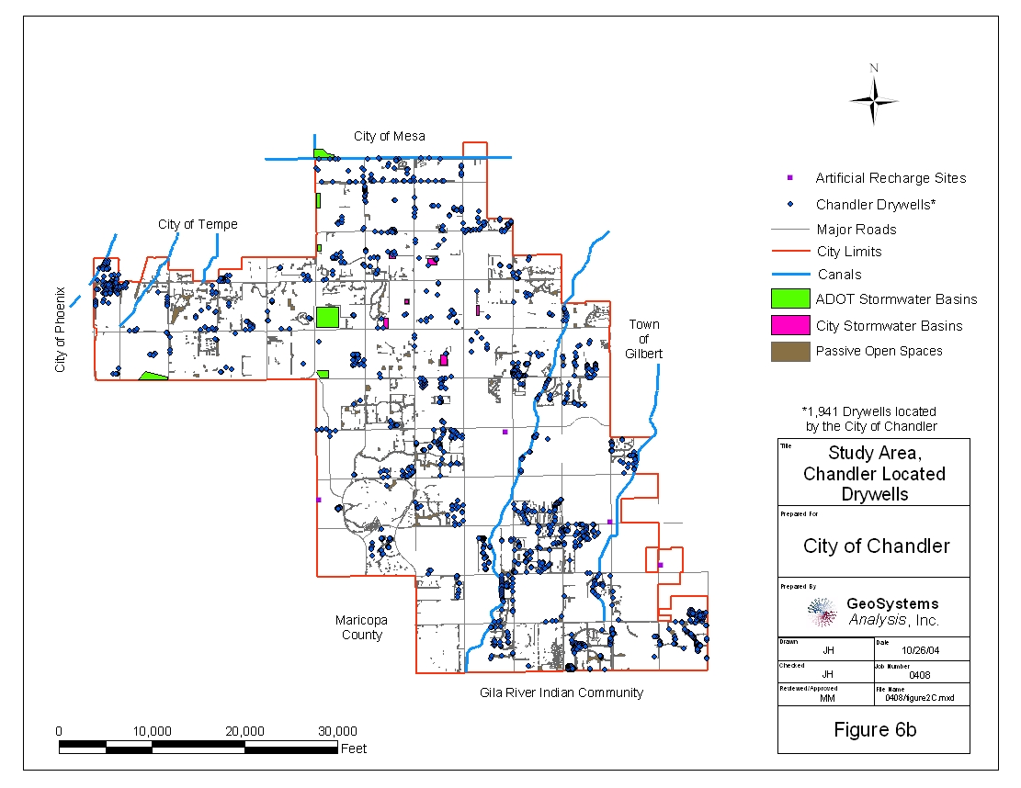
Figure 6b. Location of drywells from City of Chandler drywell database
Table 5. Drywells by study land use classification
Land Use | City Drywell Count | Percent of City  Drywells | Estimated Total Drywells**
Single Family Residential* | 795 | 41 percent | 1548
Multi Family Residential* | 241 | 12 percent | 470
Commercial | 280 | 14 percent | 545
Industrial and Airports | 52 | 3 percent | 101
Schools, Churches, Hospitals* | 263 | 14 percent | 512
Infrastructure | 54 | 3 percent | 105
Parks, Golf Courses | 55 | 3 percent | 107
Agriculture | 8 | 0 percent | 16
Water | 58 | 3 percent | 113
Desert, Vacant Land | 126 | 7 percent | 245
Total | 1932 | 100 percent | 3763
*Includes passive open spaces
**Assumes all drywells follow a similar land use classification as the City verified drywells.
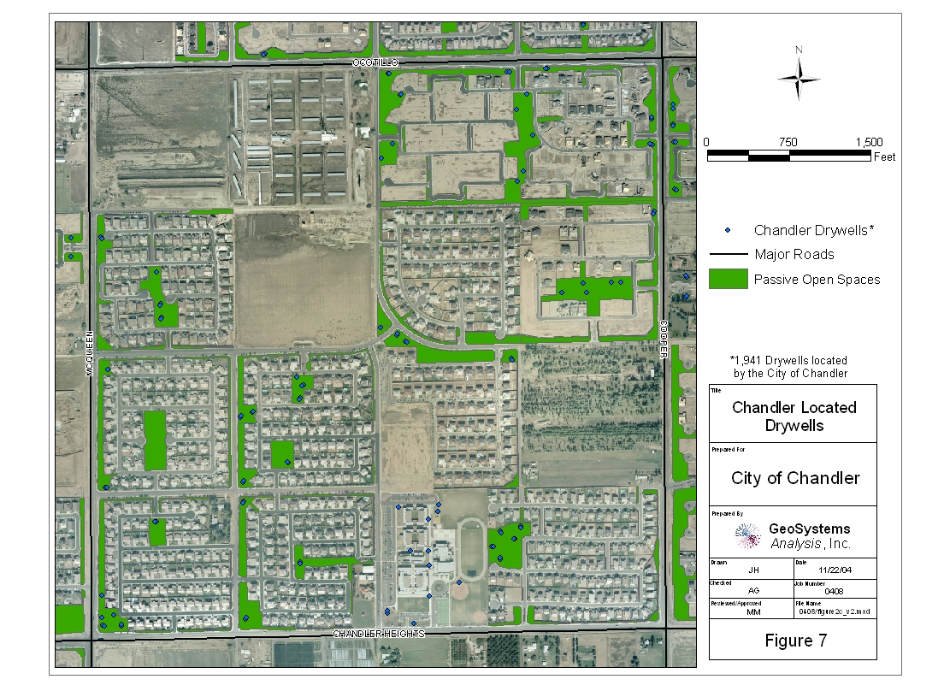
Figure 7. Example of association of drywells with passive open space.

4.5 Stormwater Detention Basin Analysis
The City drywell data shows that most drywells are located in the Passive Open Spaces land use classification, which are typically stormwater retention basins. Figure 7 shows an example of drywells associated with passive open space. These stormwater retention basins are required to be constructed such that the water depth resulting from a 100-year, two-hour storm is limited to a maximum of three feet and the percolation rates are sufficient to drain the basin in less than thirty-six hours. These basins are typically planted with turf grass and irrigated. For vacant land and agricultural areas, it was assumed that retention basins are on-site, non-irrigated, and have native vegetation.

5.0 Stormwater Runoff Estimates
The NRCS-CN runoff equation (SCS, 1986) is widely used to estimate runoff because it gives reasonable results under a variety of conditions and few other practicable methods exist for obtaining a priori estimates of runoff (Dingman 2001). However, the method does not take into account the time distribution and duration of storms, and it tends to overpredict runoff for discontinuous storms. The Rational method was also evaluated, and for this study approximately doubled the estimated surface water runoff values over the NRCS-CN method (Appendix I). Appleyard (1995), working in western Australia, also found that actual urban runoff was approximately half of the estimated runoff using a Rational method type approach. Consequently, the NRCS-CN method was chosen for this study, as it provides more conservative estimates of runoff.
In estimating stormwater runoff from precipitation and land surface cover data, the following assumptions were made:
- All runoff in the city is retained in the city, in either retention basins or drywells.
- Water that would be pumped from the older retention basins in downtown Chandler only collects during large storms, and is an insignificant percent of the total surface water runoff budget.
- On average, precipitation is uniformly distributed throughout the city, and can be classified as described in Section 3.0.
- The Soil Survey for Eastern Maricopy County (SCS, 1974) is adequate for estimating soil types within the City.
- Land cover and land use types discussed in Section 4.0 were used.
The NRCS runoff equation is:
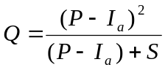 [5.3-1]

Where Q is runoff (inches), P is precipitation (inches), I_{a} is the initial abstraction of precipitation (inches), and S is the potential maximum retention after runoff begins (inches). Studies of many small agricultural watersheds have found that I_{a} is a function of S according the following equation (SCS (1986)):
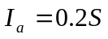 [5.3-2]

Substituting equation 5.3-2 into equation 5.3-1 gives:

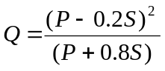 [5.3-3]

S is related to the soil and cover conditions through the curve number (CN). S can be determined from CN using the following equation:

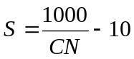 [5.3-4]

CN ranges from 0 to 100, increasing with runoff potential and impermeability (SCS 1986).

The precipitation runoff function (Equation 5.3-3) is parabolic. Runoff, Q, decreases with decreasing precipitation, P, to a P where Q = 0. As P decreases further from the minima where Q = 0, Q then increases. Consequently, the P minima was determined for each CN value, and Q was defined as 0 for all P events less than the minima.

Runoff was estimated using the NRCS-CN method for the land surface cover and the land use category estimates for dry, normal, and wet years. Estimated storm water runoff volumes were then calculated by multiplying the estimated runoff depth from each average precipitation event by the number of precipitation events per precipitation range (Table 2). Runoff volumes from all storms for dry, normal, and wet years were then combined for a yearly total runoff volume for dry, normal and wet years for land surface cover (Table 6a) and land use (Table 6b).
Table 6a. NRCS-CN Method runoff estimates by surface cover type

 | Curve Number | Dry | Normal | Wet
Surface Cover |  | Runoff (afa)
Impervious | 98 | 1870 | 4130 | 8800
Turf | 71 | 20 | 40 | 140
Agriculture | 81 | 30 | 70 | 230
Vacant | 87 | 40 | 120 | 360
Other | 96 | 170 | 480 | 1350
Total Runoff |  | 2130 | 4840 | 10880
Total Precipitation |  | 13550 | 24810 | 47200
Percent of Precipitation to Runoff |  | 16 percent | 20 percent | 23 percent

Table 6b. NRCS-CN Method runoff estimates by land use category

Land Use | Curve Number | Dry | Normal | Wet
Land Use | Curve Number | Runoff (afa)
Single Family Residential | 91 | 640 | 1710 | 4290
Multifamily Residential | 94 | 110 | 280 | 660
Commercial | 96 | 200 | 490 | 1090
Industrial | 92 | 180 | 460 | 1140
Schools, Churches, Hospitals | 92 | 50 | 150 | 370
Infrastructure | 98 | 140 | 310 | 650
Parks | 78 | 30 | 60 | 150
Agriculture | 75 | 100 | 100 | 300
Vacant | 80 | 50 | 130 | 420
Total Runoff |  | 1500 | 3690 | 9070
Total Precipitation |  | 13550 | 24800 | 47200
Percent of Precipitation to Runoff |  | 11 percent | 15 percent | 19 percent

Depending on the precipitation year and the method, estimates of total runoff range from 1,500 to 10,900 afa. Depending on the total water available from precipitation, runoff as a fraction of precipitation ranges from 11 to 23 percent. Table 6c shows the estimated annual runoff and runoff as a percent of precipitation by precipitation range. Approximately half the total predicted stormwater runoff occurs from precipitation events greater than 1 inch per day, with over 90 percent of the predicted runoff occurring from events greater than 0.4 inches per day.
Table 6c. Estimated total annual runoff and percent of total runoff by precipitation range

Precipitation Year | Precipitation Range (inches)
Precipitation Year | 0 - 0.2 | 0.2 - 0.4 | 0.4 - 0.6 | 0.6 - 0.8 | 0.8 – 1.0 | Above 1.0
Runoff (afa)
Dry | 6 | 196 | 265 | 211 | 235 | 531
Normal | 7 | 274 | 572 | 664 | 633 | 1525
Wet | 11 | 411 | 1060 | 1187 | 1271 | 5121
Runoff as Percent of Precipitation
Dry | 0 percent | 14 percent | 18 percent | 15 percent | 16 percent | 37 percent
Normal | 0 percent | 7 percent | 16 percent | 18 percent | 17 percent | 41 percent
Wet | 0 percent | 5 percent | 12 percent | 13 percent | 14 percent | 57 percent

The NRCS-CN method is generally considered appropriate to model storms greater than 0.5 inches per day (SCS, 1986). Estimated runoff values from all precipitation events in the Chandler area smaller than 0.5 inches per day ranged from 12 to 25 percent, consequently, the error associated with using the NRCS-CN method in this range is likely low. The primary source of error is the assigned curve number: relatively small changes in the curve number could result in a 20 percent or greater change in predicted runoff.

6.0 ENHANCED GROUNDWATER Recharge Estimates
Runoff flowing to retention basins and drywells will either evaporate/evapotranspire or infiltrate into the soil. Captured stormwater entering drywells contributes directly to groundwater recharge as it bypasses the root zone of most plants, and is unlikely to evapotranspire. Water infiltrating into surface soils of retention basins may either evapotranspire or recharge to groundwater. Finally, a separate fraction of the precipitation that does not run off and instead directly infiltrates through turf-grass and agriculture soils will recharge as a result of irrigation in excess of the evapotranspirative plant needs.
In-situ monitoring in stormwater retention basins in southeastern Arizona over a three year period in indicated that 36 percent, 43 percent, and 80 percent of stormwater runoff became groundwater recharge in dry, normal, and wet years, respectively (GSA, 2004). The referenced study area receives approximately 75 percent more precipitation (at 14.8 inches per year) than the Chandler area. However, the City retention basins contain drywells and are irrigated, maintaining high moisture contents that facilitate recharge. Therefore, these recharge values are considered to provide a conservative estimate of groundwater recharge rates in Chandler retention basins.

6. 1 Groundwater Recharge Estimates from Land Surface Cover Method
Potential groundwater recharge from land surface cover runoff (from Table 6a) were estimated by multiplying the recharge factors of 36, 43, and 80 percent by predicted runoff for dry, normal, and wet years, respectively. Groundwater recharge rates determined by this method ranged from 770 to 8,700 afa depending on the precipitation year. Over ten years (8 normal, 1 dry, 1 wet), the average estimated groundwater recharge from stormwater capture is approximately 2,610 afa (Table 7).
Table 7. Estimated groundwater recharge estimates from Land Surface Cover runoff
Source* | Dry Year | Normal Year | Wet Year
Source* | Estimated Potential Recharge¹ (afa)
All Surfaces | 770 | 2080 | 8700
Ten Year Average (afa) | 2610
¹Estimated Recharge by applying recharge factors of 0.36, 0.43, and 0.8 to dry, normal, and wet years respectively (GSA, 2004)

6.2 Groundwater Recharge Estimates from Land Use Category Method
For the Land Use Category approach, the ten land use categories were grouped into three general recharge categories, each with its own assumptions for estimating potential recharge:
Assumptions for Single Family Residential, Multi Family Residential, School, Hospitals, Churches, and Park Land Use Categories:
- All stormwater runoff reports to retention basins containing drywells in open passive space.
- 50 percent of the passive open space area is walkways and side-slopes, 50 percent is retention basin floors.
- The depth of stormwater reporting to the basins is calculated from the total stormwater runoff volume divided by retention basin floor area.
- Average pan evaporation rate for the City is 0.3 inches per day (NOAA, 1983).
- Retention basins are landscaped with turfgrass, and are irrigated on average every 48 hours (Capps, 2004).
- Stormwater runoff collected in the retention basins drains within 36 hours and is subject to 0.3 inches per day of evaporation before the next irrigation (0.6 inches total).
Assumptions for Commercial, Infrastructure, and Industrial Land Use Categories:
- Runoff from all surfaces reports directly to drywells.
- All runoff is credited to potential recharge.
Assumptions for Agriculture and Vacant Land Use Categories:
- Runoff from all surfaces reports to retention basins without drywells or irrigation.
- The majority of runoff is lost to evapotranspiration and groundwater recharge is negligible.
Potential groundwater recharge estimates, using the data from Table 6b, are shown in Table 8.
Table 8. Estimated groundwater recharge from Land Use Category runoff.
Source | Dry Year | Normal Year | Wet Year
Source | Estimated Groundwater Recharge (afa)
Single Family Residential, Multi Family Residential, School and Park | 630 | 1790 | 4730
Commercial, Infrastructure and Industrial | 520 | 1260 | 2880
Agriculture and Vacant | 0 | 0 | 0
Total (afa) | 1150 | 3050 | 7610
Ten Year Average (afa) | 3320

With this approach, stormwater runoff was estimated to contribute from 1,150 to 7,610 afa to potential groundwater recharge depending on the precipitation year. Over ten years (8 normal, 1 dry, 1 wet), the average estimated groundwater recharge rate from storm water runoff is approximately 3,320 afa.

6.3 Turfgrass and Agriculture Land Infiltration and Groundwater Recharge
The majority of precipitation that does not run off infiltrates into the soil profile. As discussed in Section 2.1, most precipitation infiltrating into natural southwestern deserts returns to the atmosphere through evapotranspiration. However, in irrigated agriculture and turfgrass areas, the soil profile is maintained at high moisture contents, and irrigation is supplied in excess of plant consumptive use in order to prevent the buildup of salinity in the soil. Consequently, groundwater recharge will occur from a portion of precipitation infiltrating into turfgrass and agriculture land.
To estimate recharge from precipitation infiltrating turfgrass and agriculture areas, the following conservative assumptions were made:
- Turfgrass and agricultural crops planted within the City have low (i.e. citrus) to moderate (i.e. ryegrass, fescues) salt tolerance (Ayers and Westcot, 1989).
- Irrigation water ranges from 400 to 800 mg/l of total dissolved solids, depending on the source (CAP, SRP, or groundwater). These values correspond to an approximate electrical conductivity of 0.6 to 1.2 DS/m (Hem, 1982).
- Root zone salinity below 2.25 DS/m adversely affects the yield of citrus (Ayers and Westcot, 1989) and is considered to be high salinity for turfgrass (Turgeon, 1999). Therefore, a minimum leaching factor of 0.2 (20 percent) is required: 20 percent more water is needed for irrigation than the plants use.
Under these assumptions, at least 20 percent of the precipitation on turfgrass will be leached under normal irrigation practices and result in groundwater recharge. Depending on the precipitation year, estimates of the contribution of turf grass and agriculture infiltration to potential recharge range from 690 to 2,230 afa (Table 9). Over 10 years (8 normal, 1 dry, 1 wet), the average potential recharge rate is estimated to be approximately 1,290 afa.
Table 9. Turfgrass and agriculture groundwater recharge estimates
 | Dry Year | Normal Year | Wet Year
Source | Estimated Groundwater Recharge (afa)
Turf grass Deep Percolation | 270 | 500 | 900
Agriculture Deep Percolation | 420 | 750 | 1320
Total | 690 | 1250 | 2230
10 Year Average | 1290

6.4 Estimated Groundwater Recharge Summary
Estimates of groundwater recharge were made using two different approaches (Tables 7 and 8). In addition, groundwater recharge from precipitation infiltrating into irrigated agriculture and turfgrass was estimated (Table 9). The total estimated groundwater recharge rate for the Land Surface Cover approach ranges from 1,460 to 10,930 afa depending on the precipitation year (Table 10). The total estimated groundwater recharge rate using the Land Use Category approach ranges from 1,840 to 9,830 afa depending on the precipitation year (Table 10). Over 10 years (8 normal, 1 dry, 1 wet), the average groundwater recharge rate is estimated to range from 3900 afa to 4600 afa (Table 10).
Table 10. Estimated groundwater recharge summary
Source | Dry Year | Normal Year | Wet Year
Source | Estimated Groundwater Recharge (afa)
Land Surface Cover Estimates | 770 | 2080 | 8700
Land Use Category Estimates | 1150 | 3050 | 7610
Agriculture and Turf grass Deep Percolation | 690 | 1250 | 2230
Total Land Cover Type Estimate (afa) | 1460 | 3330 | 10930
Land Cover Type Estimate 10 Year Average (afa) | 3900
Total Land Use Category Estimate (afa) | 1840 | 4300 | 9830
Land Use Category Estimate 10 Year Average (afa) | 4610

7.0 Conclusions
This study provides a preliminary assessment of the potential increase in groundwater recharge that has resulted from urbanization and stormwater retention in the City of Chandler. The results indicate that urbanization and stormwater retention has potentially enhanced natural groundwater recharge rates by as much as 4,600 afa. Pre-urbanized natural recharge rates in the City were estimated to be as much as 191 afa.
Table 11 shows the current estimated groundwater recharge budget for the City (SGC, 2002), which includes incidental recharge from urban irrigation, turf irrigation, and lake and canal leakance. The addition of enhanced natural recharge from precipitation could increase the overall groundwater recharge budget by several thousand acre-feet per year. Consequently, groundwater recharge from stormwater runoff and capture, together with infiltration of precipitation beneath irrigated lands, represent a potentially significant water resource to the City.
Table 11. Chandler Groundwater Recharge Budget
Source |  | Recharge (afa)
Included in Chandler Model (SGC, 2002)
 | Urban Irrigation | 1670
 | Turf Irrigation | 800
 | Lake Leakance | 1550
 | Canal Leakance non-San Carlos Irrigation Project | 2920
Chandler Groundwater Model Total |  | 6940
Potential Addition from Enhanced Groundwater Recharge
 | Stormwater runoff | 2610-3320
 | Turfgrass and Agriculture Infiltration (from precipitation) | 1290
Potential Enhanced Groundwater Recharge Subtotal |  | 3900-4600
Potential Groundwater Recharge Total |  | 10840-11540

The methods and approaches used herein to estimate the amount of enhanced groundwater recharge resulting from urbanization and increased stormwater runoff are subject to error, and the estimated potential groundwater recharge rates should only be considered a first approximation. GSA has followed a conservative set of assumptions in order to minimize positive bias in the runoff assumptions and deep percolation estimates in irrigated lands. Errors that could increase the amount of estimated groundwater recharge include greater stormwater runoff than estimated, the existence of drywells and irrigated retention basins that capture runoff from vacant and agricultural land, and lower irrigation efficiencies (higher leaching factors). Errors that could decrease the amount of estimated groundwater recharge include lower drywell efficiency in commercial, industrial, and infrastructure areas, and higher evaporation and evapotransipiration in retention basins.

8.0 References
ADWR, See Arizona Department of Water Resources.

Arizona Department of Water Resources, 1991. "Drywell Recharge and Contaminant Loading in Metropolitan Phoenix, Arizona", prepared under Grant #G-009562-1 for the U.S. EPA.

Arizona Department of Water Resources, 2001. Arizona Impervious Surface Area. GIS data layer. Phoenix, Arizona.

Arizona Department of Water Resources, 2004. http://water.az.gov/adwr/Content/Publications/files/gwmgtovw.pdf

Allison, G.B., G.W. Gee, and S.W. Tyler, 1994. Vadose-zone techniques for estimating recharge in arid and semi-arid regions, Soil Soc. Amer. J. 58:6-14.

Anderson, T.W., F.W. Freethy, and P. Tucci, 1992. Geohydrology and water resources of alluvial basins in South-central Arizona and parts of adjacent states, Regional Aquifer-System Analysis- Southwest alluvial basins, AZ and Adj. States, U.S. Geol. Surv. Prof Paper 1406-B, 67 p.

Appleyard, 1995. The impact of urban development on recharge and groundwater quality in a coastal aquifer near Perth, Western Australia: Hydrogeology Journal, 3(2), 65-75.

Ayers, R.S., and D.W. Westcot, 1989. Water Quality for Agriculture: Food and Agriculture Organization Drainage Paper, 29 Rev.1. 174 pp.

Brown, P. 2004. Turfgrass Specialist, University of Arizona. Personal communication.

Capps, Greg, 2004. Water Resource Manager, City of Chandler. Personal Communication.

City of Chandler, 2002. Storm Drainage System Design: Technical Design Manual #3.

Corell, S. W., E. Corkhill, 1994. A regional groundwater flow model of the Salt River Valley-Phase II. Arizona Department of Water Resources, Hydrology Div., Modeling Report No. 8. 92 p.

de Vries, J.J. and L. Simmers, 2002. Groundwater recharge: an overview of processes and challenges, Hydrol. J. 10:5-17.

Gee, G.W. and D. Hillel, 1988. Groundwater Recharge in Arid Regions: Review and Critique of Estimation Methods. J. Hydrol. Proc., 2:255-266.

Gee, G.W., P.J. Wierenga, B.J. Andraski, M.H. Young, M.J. Fayer, and ML. Rockhold, 1993. Variations in water balance and recharge at three western desert sites, Soil Sci. Soc. Amer. J. 58:63-72.

GeoSystems Analysis, Inc., 2004. Project SP-0011 Storm water recharge feasibility analysis. Prepared for the Upper San Pedro Partnership.

Hem, J.D. (1992). Study and interpretation of the chemical characteristics of natural waters. US Geological Survey Water Supply Paper 2254, US Government Printing Office, Washington, 263pp.

Lerner, D.N., A. Issar and I. Simmers, 1990. Groundwater recharge; a guide to understanding and estimating natural recharge. International Contributions to Hydrogeology vol. 8. Heise, Hannover, FRG. 345 pp.

Lerner, D.N., 2002, Identifying and quantifying urban recharge: a review. Hydrogeology Journal 10:143–152

Los Angeles and San Gabriel Rivers Watershed Council, 2003. Water augmentation study Phase II Annual Monitoring Report. 58 pp.

McPhee, J., A. Comrie and G. Garfin. 2004. Drought and Climate in Arizona: Top Ten Question & Answers. Climate Assessment Project for the Southwest (CLIMAS). Tucson, AZ.

Maxey, G.B., and T.E. Eakin, 1949, Ground water in White River Valley, White pine, Nye, and Lincoln Counties, Nevada: Nevada State Engineer, Water Resources Bulletin 8.

National Oceanic and Atmospheric Administration (NOAA), 1982. Technical Report NWS 33, Evaporation Atlas for the Contiguous 48 United States, National Weather Service, NOAA, Washington, D.C.

Pool, D.R., 2004. Variations in climate and natural recharge in Southeastern Arizona. Water Res. Res. Submitted.

Reynolds, J. 2004. Personal communication.

Scanlon, B. R., Langford, R. P., and Goldsmith, R. S., 1999. Relationship between geomorphic settings and unsaturated flow in an arid setting: Water Resources Research, v. 35, no. 4, p. 983–999

Scanlon, B. R., Keese, K., Reedy, R. C., Simunek, J., and Andraski, B. J., 2003. Variations in flow and transport in thick desert vadose zones in response to paleoclimatic forcing (0–90 kyr): field measurements, modeling, and uncertainties: Water Resources Research, v. 39, No. 7, p. 1179

SCS. See Soil Conservation Service

SGC. See Southwest Groundwater Consultants

Soil Conservation Service, 1986, Urban Hydrology for Small Watersheds, Technical Release 55, 2nd ed., U.S. Dept. Agriculture, NTIS PB87-101580, Springfield, Virginia, June.

Soil Conservation Service, 1974, Soil Survey: Eastern Maricopa and Northern Pinal Counties Area, Arizona. United States Department of Agriculture.

Southwest Groundwater Consultants, 2002. Shallow aquifer management feasibility study: Task 1 Hydrogeology. City of Chandler WA 0126-101.

Turgeon, A.F. 1999. Turfgrass Management, 5th Edition. Prentice Hall. 392 pp.

